Demand-Weighted ATM Network Optimization Under Scenario-Based Demand Variability
Ciara Cameron
MSML 604-PCS3
Repository: https://github.com/Ciaracam/atm-optimization.git

Abstract
Credit unions rely on ATM networks to provide accessible financial services but determining where to place ATMs requires balancing installation costs with member accessibility. Placing too few ATMs increases travel distance, while placing too many leads to unnecessary cost and underutilized infrastructure.
This project models ATM placement as a demand-weighted facility location problem, where the goal is to minimize total weighted travel distance between members and ATM locations. Unlike standard approaches that treat all members equally, this model incorporates demand weights to better reflect real-world usage patterns. The analysis evaluates multiple demand scenarios, including Urban Demand Increase, Suburban Demand Increase, and Demand Variability, as well as sensitivity to reductions in the number of ATM locations.
Results show that optimal ATM locations remain largely stable across different demand scenarios, suggesting that geographic structure plays a dominant role in placement decisions. However, overall outcomes, measured by weighted travel distance, vary significantly depending on how demand is distributed. Reducing the number of ATM locations leads to a disproportionate increase in travel burden, particularly in high-demand regions, highlighting the impact of infrastructure constraints.
These findings demonstrate that while ATM placement decisions may appear intuitive due to geographic clustering, demand-weighted optimization provides a formal and quantitative framework for evaluating tradeoffs between efficiency and accessibility. The results emphasize the importance of accounting for demand variability and resource limitations when designing real-world ATM networks.

Introduction
Credit unions rely on ATM networks to provide accessible financial services to their members. However, determining where to place ATMs is not straightforward. Placing too few ATMs can increase travel distance for members, while placing too many can lead to unnecessary costs and underutilized infrastructure.
This project focuses on using optimization to determine effective ATM placement strategies while accounting for differences in member demand across regions. Instead of treating all members equally, the model incorporates demand weights to better reflect how frequently different areas use ATM services.
Another key part of this project is understanding how the model behaves under different conditions. In real life, demand is not static. Some areas may experience higher usage than others, and these patterns can change over time. Because of this, the project goes beyond solving a single optimization problem and instead looks at how ATM placement, travel distance, and how easily members can access ATM locations change under different demand scenarios. These scenarios include Urban Demand Increase, Suburban Demand Increase, and Demand Variability, allowing the model to capture both structured and uncertain changes in demand distribution.

Related Work
The ATM placement problem can be viewed as a facility location problem, which is a well-studied area in optimization. One common formulation is the p-median problem, where the goal is to minimize the total distance between demand points and selected facility locations (Daskin, Snyder, & Berger, 2012).
Another important model is the Fixed Charge Facility Location Problem, which balances the cost of opening facilities with transportation or service costs. These models highlight a key tradeoff between facility cost and service distance, a structure that aligns with the standard optimization frameworks (Boyd & Vandenberghe, 2004).
More recent work builds on these models by accounting for uncertainty and changes in demand over time. Instead of assuming demand is fixed, these approaches evaluate how solutions perform under different conditions, which is more realistic in practice.
This project takes that idea a step further by focusing on three main extensions. First, it incorporates a demand-weighted objective so that areas with higher usage have more influence on the results. Second, it uses scenario-based analysis to understand how placement decisions change when demand shifts across regions. Third, it looks at sensitivity to the number of ATM locations to capture how infrastructure constraints impact overall performance.
Rather than just finding one optimal solution under fixed conditions, this approach focuses on how stable those placement decisions are when conditions change. This gives a more realistic view of how ATM placement performs in situations where demand is not constant.

Problem Formulation
The ATM placement problem is modeled as a demand-weighted facility location problem.
We are given:
- Member locations
- Candidate ATM locations
- Demand weights for each member
- A fixed number of ATM locations to place

The goal is to minimize the total weighted travel distance between members and their assigned ATM locations. This objective prioritizes minimizing travel distance for higher-demand members, ensuring that areas with greater usage have proportionally greater influence on ATM placement decisions.
$$min\sum_{i}{\sum_{j}{w_{i}⋅d_{ij}⋅x_{ij}}}$$
Where:
- $w_{i}$: demand weight associated with member $i$
- $d_{ij}$: distance between member $i$ and ATM location $j$
- $x_{ij}$: binary variable indicating whether member $i$ is assigned to ATM location $j$

Subject to the following constraints:
$$\sum_{j=1}^{m}{x_{ij}=1} ∀i$$
Each member is assigned to exactly one ATM location.
$$x_{ij}≤y_{i} ∀i,j$$
Members can only be assigned to ATM locations that are selected.
$$\sum_{j=1}^{m}{y_{j}=K}$$
Exactly K ATM locations are selected.
$$x_{ij},y_{j} ∈ \{0,1\}$$
This formulation ensures that the model selects ATM locations and assigns members in a way that minimizes total weighted travel distance while respecting the constraint on the number of ATM locations. The constraints require that each member is assigned to exactly one ATM location, assignments are only made to selected ATM locations, and exactly K ATM locations are chosen. This essentially follows a standard facility location setup, where you’re balancing assignment costs with the limits on how many locations you can have.
Note on Model Assumptions. The original formulation included a budget constraint for ATM installation. This was simplified by fixing the number of ATMs (K), which is equivalent to assuming equal costs and allows for clearer analysis. This simplification allows the model to focus on placement tradeoffs without introducing additional cost variability, making results easier to interpret across scenarios.
Methodology
Since real credit union member data is not publicly available, synthetic data was generated using geographic anchor points in the Maryland and Washington, DC area. These anchors were defined using latitude and longitude coordinates for key regions, including the DC Metro area (with a focus on Prince George’s County), as well as Silver Spring, Bowie, Annapolis, and Waldorf.
In this context, the DC Metro area (including Prince George’s County) and Silver Spring are treated as higher-density urban areas, while Bowie, Annapolis, and Waldorf represent more suburban or lower-density regions. This distinction is important because it drives both how members are distributed and how demand is assigned across locations.
Member locations were generated by sampling from normal distributions centered at each anchor point. Each region was given a different spread, with tighter clustering in urban areas and more dispersion in suburban regions. This creates more realistic geographic patterns rather than assuming members are evenly distributed.
The dataset consists of approximately 215 simulated members across five regions, with more members concentrated in urban areas and fewer in suburban regions to reflect real-world population patterns.
Candidate ATM locations were defined using a fixed set of real geographic coordinates across Maryland and nearby cities, including Washington, DC, Hyattsville, Bowie, Annapolis, Waldorf, Silver Spring, Rockville, Baltimore, and Frederick. These represent potential placement sites rather than individual machines and are meant to reflect realistic options such as commercial centers or population centers. While this improves realism, it still simplifies the full set of constraints that would exist in a real placement decision.
Distances between members and candidate ATM locations were computed using Euclidean distance on latitude–longitude coordinates as a simple approximation of travel distance. This approach is computationally efficient and consistent across all scenarios, but it does not account for road networks, traffic patterns, or geographic barriers. Because of this, the results should be interpreted as relative accessibility rather than exact travel time. In a real-world setting, this could be replaced with a more realistic distance measure, such as road-network distance, to better reflect how people travel.
Demand weights were assigned based on region to reflect differences in expected ATM usage. These weights represent how likely members are to use ATM services, rather than exact transaction counts, with higher values meaning those members are more likely to use ATMs. The weights capture differences in demand within each scenario.
In the baseline scenario, urban regions were given higher weights and suburban regions lower weights to reflect differences in expected usage.
To better understand how placement decisions respond to changing conditions, scenario-based adjustments were applied to the demand weights. These include:
- Urban Demand Increase: increases demand in DC Metro and Silver Spring
- Suburban Demand Increase: increases demand in Bowie and Waldorf
- Demand Variability introduces random variation in demand weights across all members
These scenarios allow the model to capture both structured shifts in demand and more unpredictable changes in usage patterns.
The model assumes that each ATM location has unlimited service capacity, meaning it can serve any number of members. While this simplifies the problem, it does not reflect real-world constraints such as transaction limits or congestion at high-traffic locations.
The model was implemented in Python using NumPy for data generation and distance computation. A fixed random seed was used to ensure reproducibility across all scenarios, so that results remain consistent across multiple runs. Distance calculations were performed using vectorized operations for efficiency.
Overall, this approach allows for a controlled and flexible way to evaluate how ATM placement decisions respond to changes in demand distribution and infrastructure constraints, while still maintaining a level of realism in the underlying data.

Sensitivity Analysis
The model is also tested under different infrastructure levels by testing the number of available ATM locations:
- K = 3 ATM Locations
- K = 2 ATM Locations
The baseline model uses K = 3 ATM locations, and K = 2 is used to evaluate what happens when the number of locations is reduced.
This allows for analysis of how reducing the number of ATM locations impacts overall travel distance and accessibility. It highlights the tradeoff between maintaining accessibility and operating under more limited infrastructure.

Results
The results evaluate how ATM placement decisions, overall travel distance, and access to ATM locations change across different demand scenarios and different numbers of ATM locations. The analysis focuses on three key aspects: (1) consistency of ATM placement, (2) baseline model behavior, and (3) sensitivity to demand shifts and reduced ATM availability.
Figure 1: Member Distribution and Candidate ATM Locations
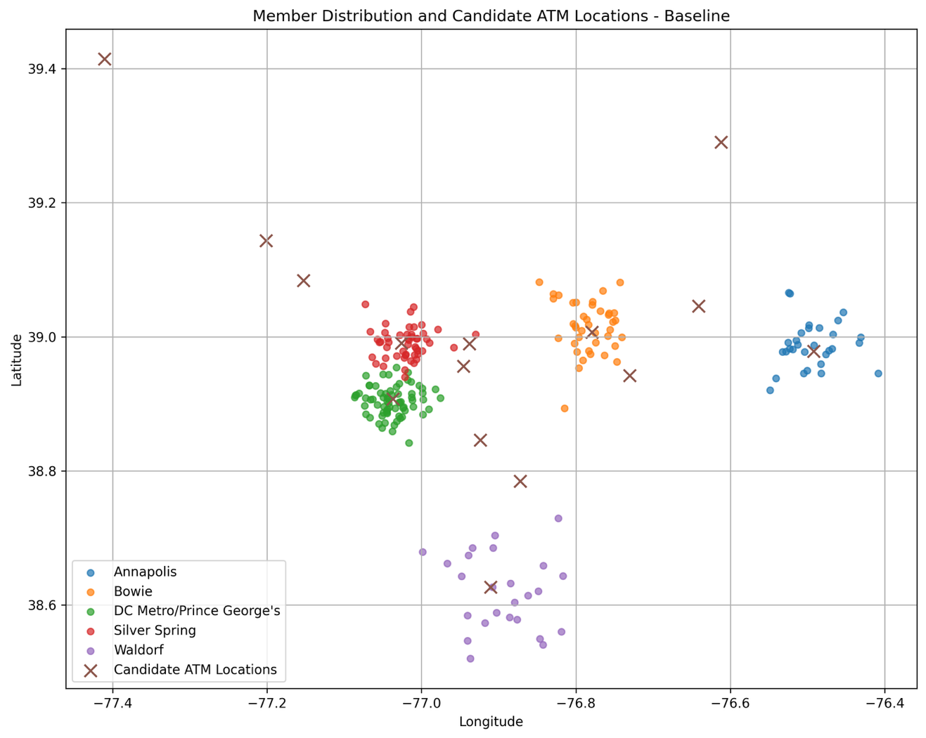
This figure shows the geographic distribution of members along with candidate ATM locations before any placement decisions are made, which helps explain why the model chooses certain ATM locations.
Figure 2: Member Assignment to Selected ATM Locations
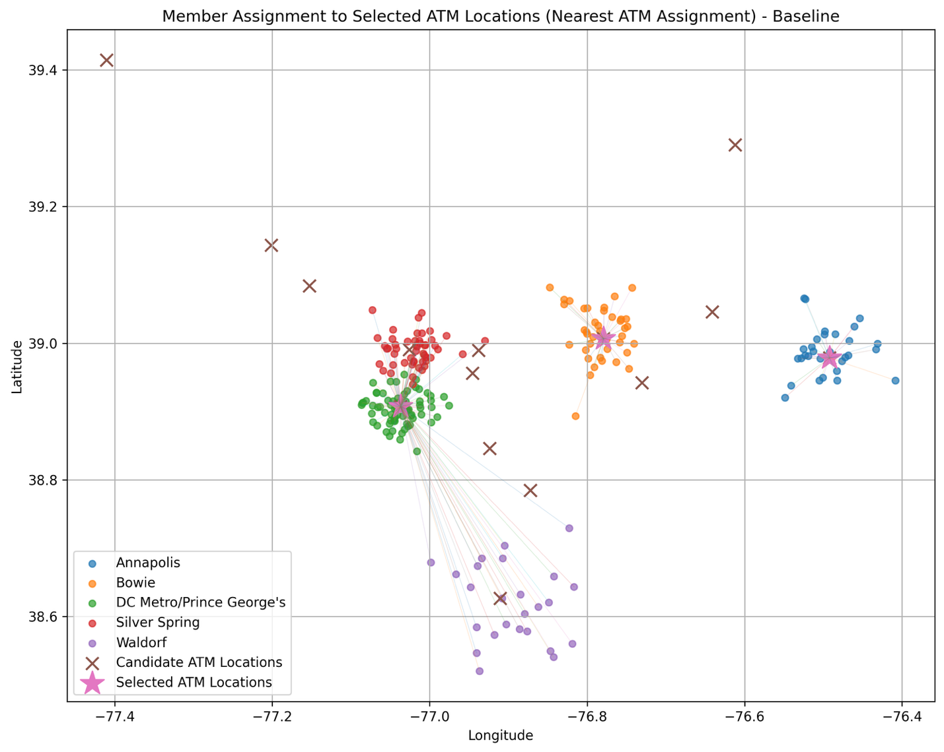

Each member is assigned to the nearest selected ATM location by the model. The lines show which ATM each member is connected to, making it easy to see how the model keeps travel distances as low as possible. Members in more spread-out suburban areas usually end up with longer trips compared to those in denser urban areas.

Figure 3: Coverage Model (Service Radius r = 0.08)
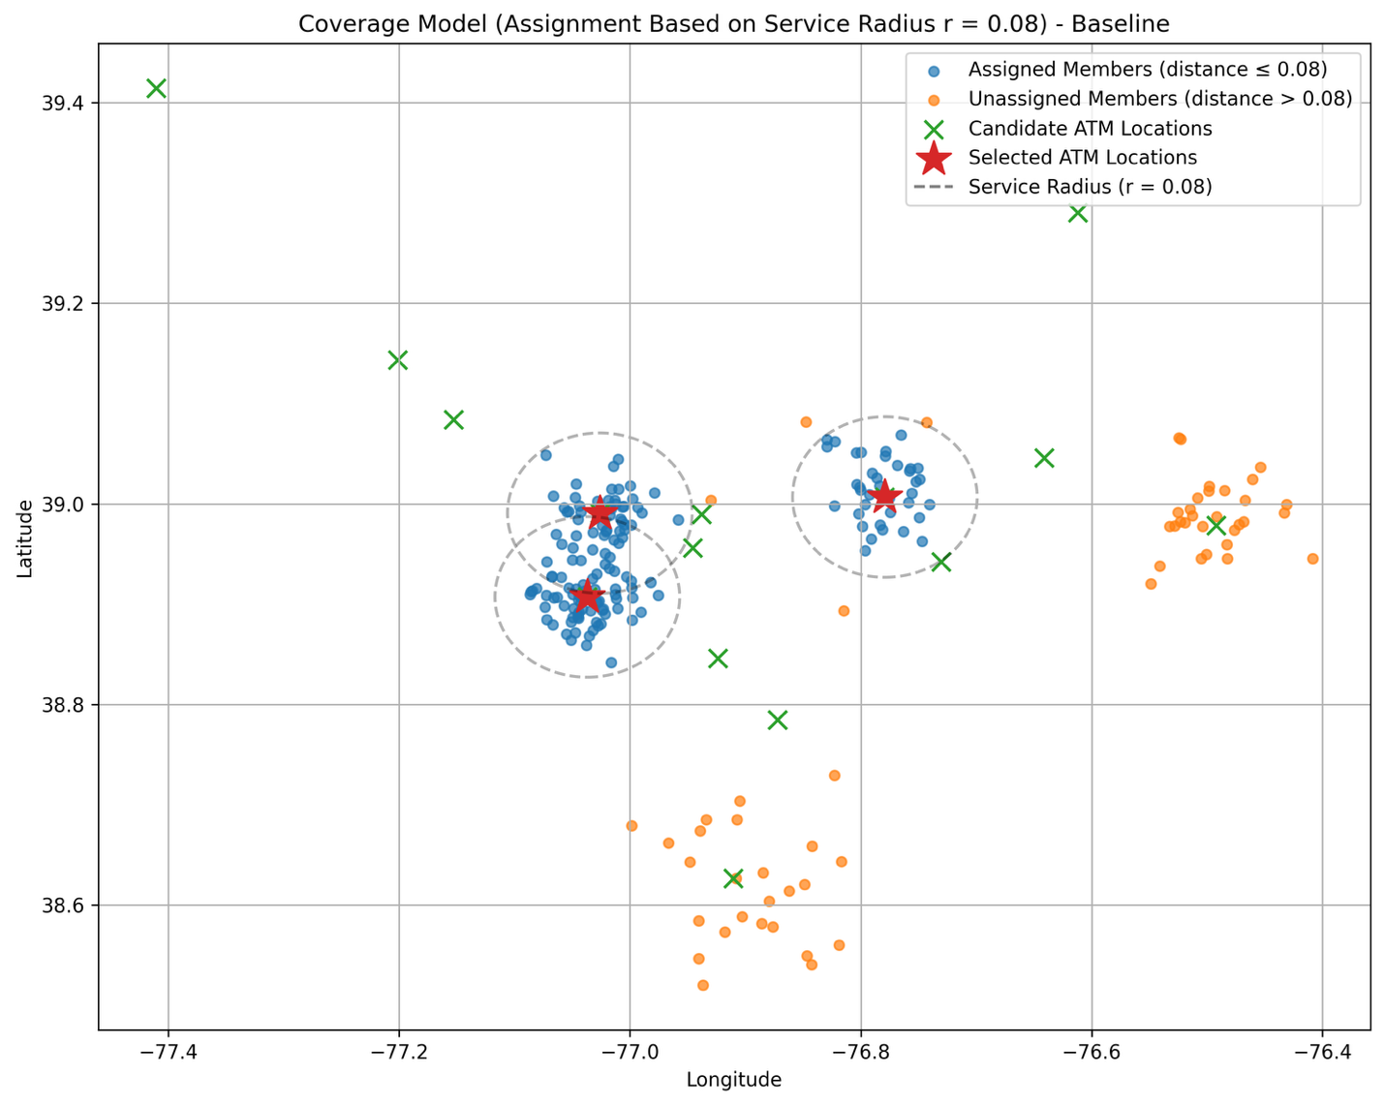
Members are classified based on whether they fall within a fixed service radius of a selected ATM location. A member is considered assigned if their distance to the nearest selected ATM is ≤ r = 0.08 and unassigned otherwise. The dashed circles show the service radius around each selected ATM, making it clear where coverage ends. Members outside these areas are not served under the coverage constraint.

Figure 4: Consistent ATM Selections
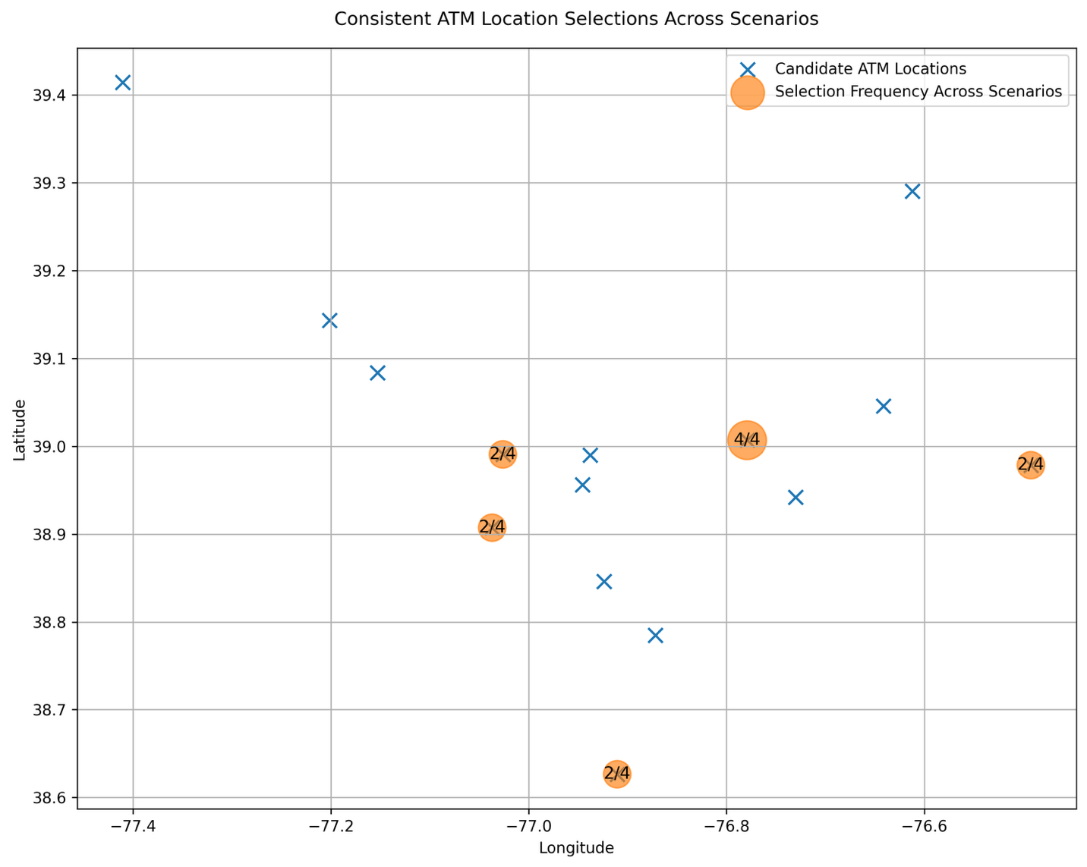

Candidate ATM locations are shown with markers indicating how often each site gets picked across scenarios. Several locations are selected consistently across scenarios, which indicates that geographic clustering plays a larger role in placement than changes in demand.

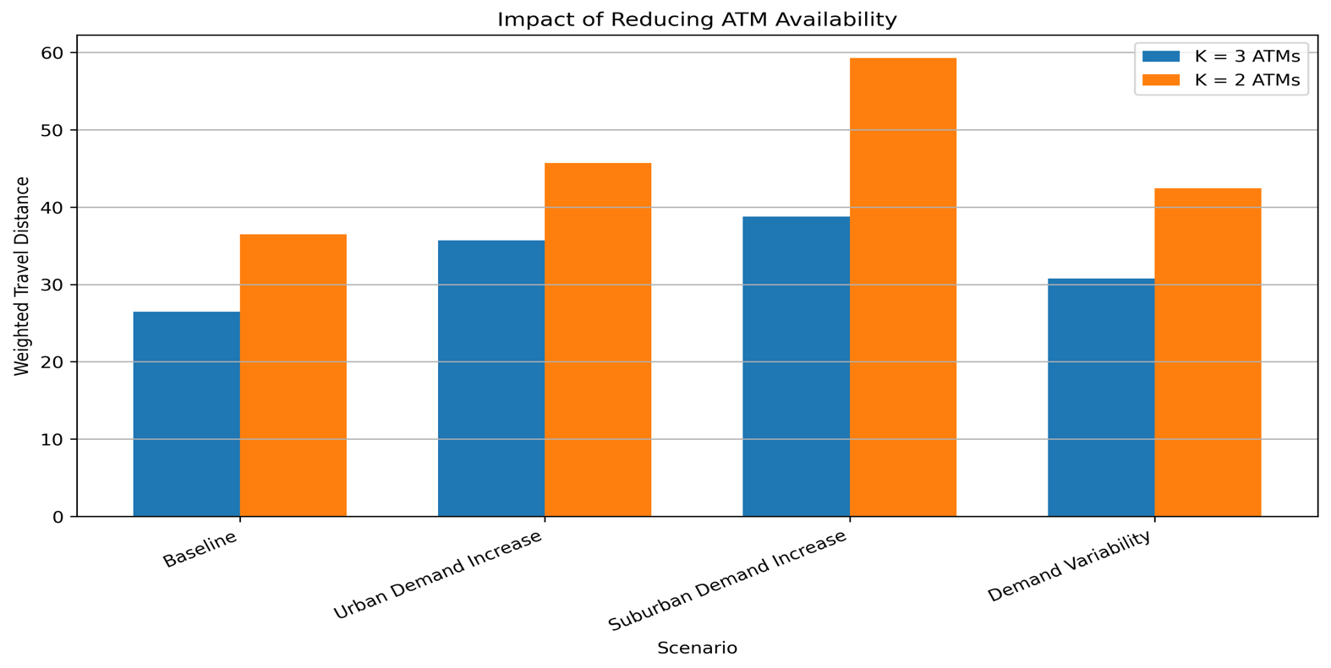
Figure 5: Impact of Reducing ATM Availability (K=2 vs K=3)

Bars compare total weighted travel distance across scenarios for different numbers of ATM locations. Reducing the number of ATM locations significantly increases travel distance across all scenarios, with the largest impact observed under suburban demand conditions.

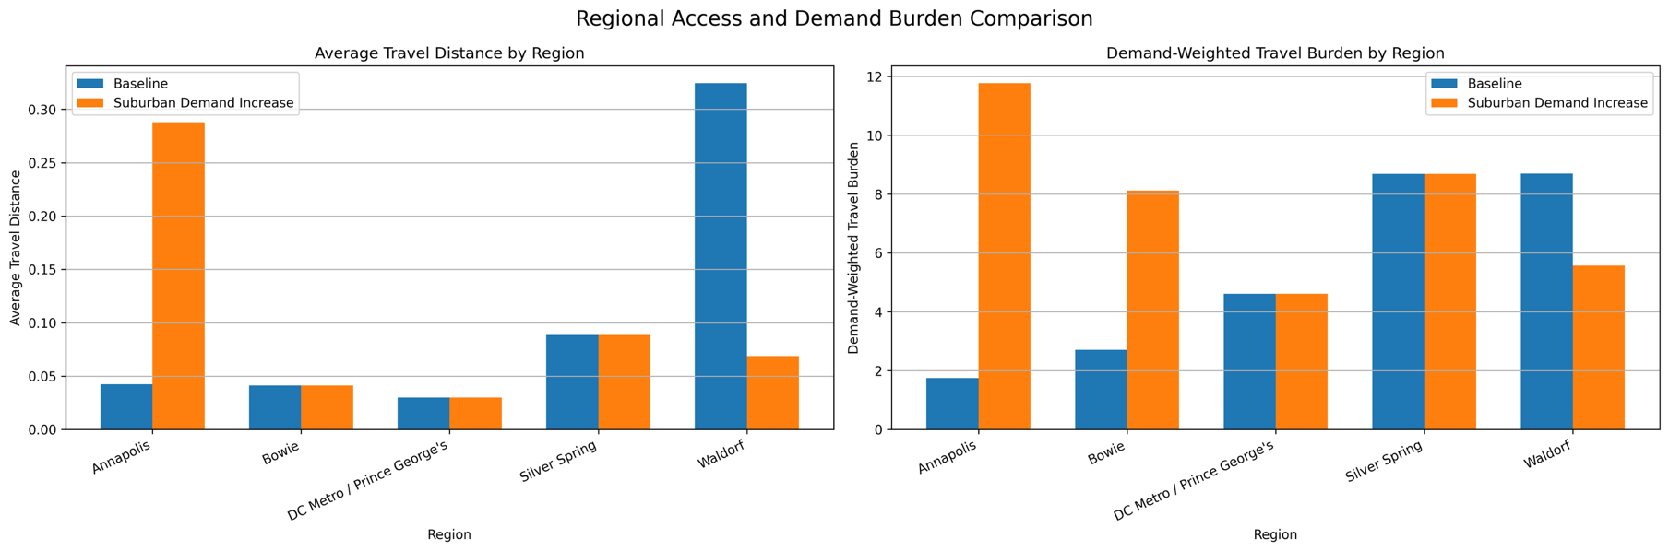
Figure 6: Regional Access and Demand Burden Comparison
The left chart shows average travel distance by region, while the right chart shows demand-weighted travel burden. Suburban regions experience larger changes under increased demand, indicating greater sensitivity compared to more stable urban areas.

Figure 7: Member Assignment to Selected ATM Locations (Nearest ATM Assignment) – Suburban Demand Increase
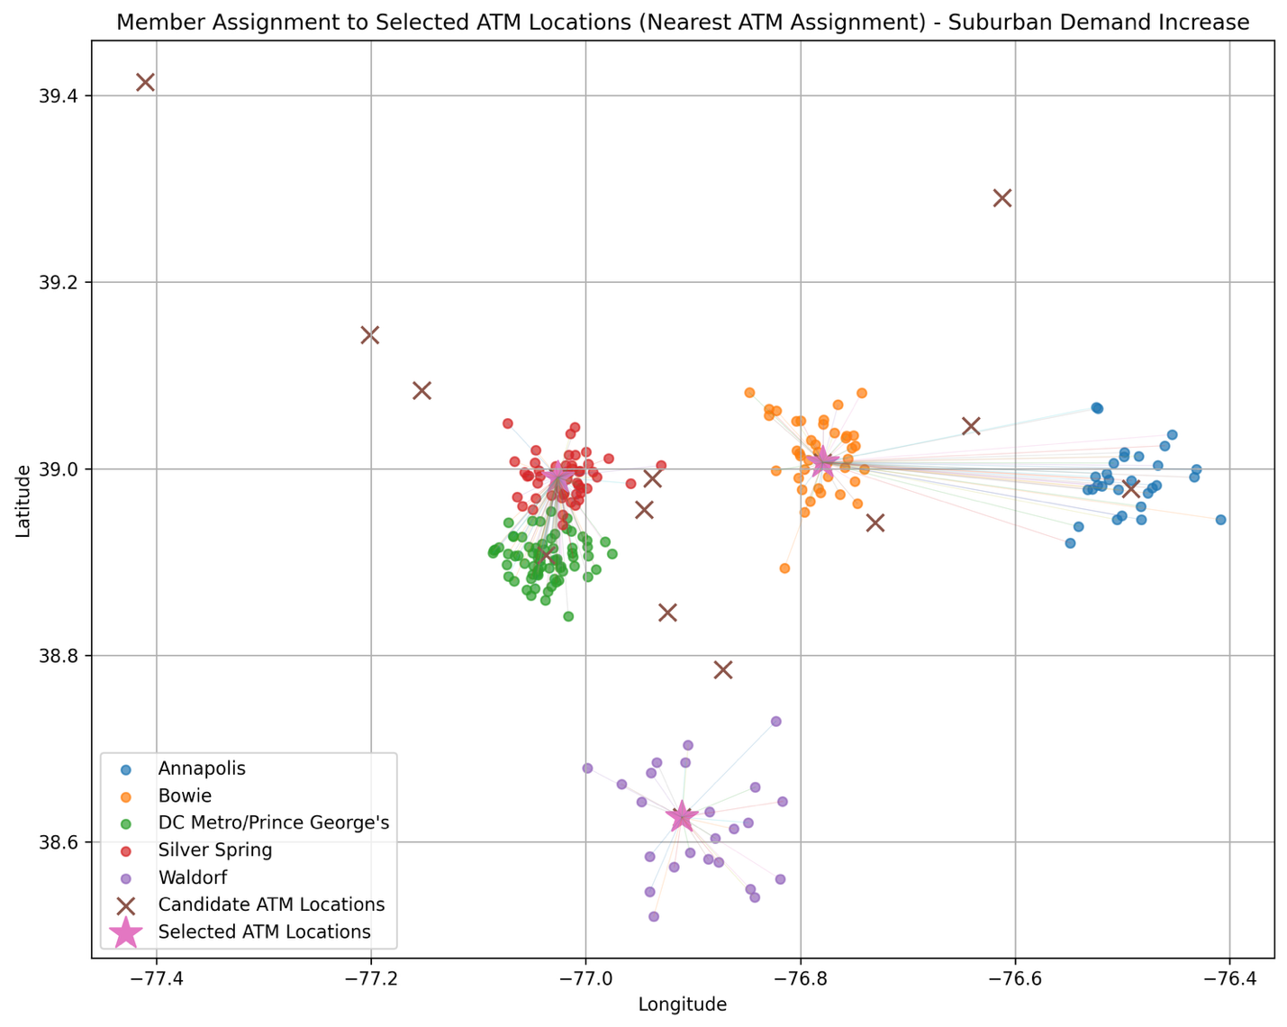

Under suburban demand increase, more members end up being assigned to the Waldorf location, showing a clear shift toward suburban areas while the ATM locations themselves stay mostly the same. Because these suburban regions now carry more demand, they have more influence on the model, which increases travel distances for some urban clusters. This shows how sensitive the results are to changes in how demand is distributed.

Analysis
The results reveal several important patterns in how the model behaves under different conditions.
First, ATM placement decisions are highly stable across demand scenarios. In the selection frequency results (Figure 4), several ATM locations are consistently chosen across all scenarios. This suggests that geographic structure, specifically the location of member clusters, plays a large role in determining optimal placement. Even when demand shifts between urban and suburban regions, the model continues to select centrally located sites.
However, while placement remains stable, total weighted travel distance is very sensitive to demand distribution. In the regional results (Figure 6) and the suburban demand scenario map (Figure 7), changes in demand weights lead to noticeable differences in travel distance and demand-weighted burden. This indicates that the impact of a given ATM network depends not just on where ATM locations are placed, but how demand is distributed across regions.
Another key finding is the impact of reducing the number of ATM locations. The sensitivity analysis (Figure 5) suggests that decreasing from three ATM locations to two results in a material increase in total travel distance across all scenarios. To quantify this effect, total weighted travel distance increases across all scenarios when reducing from three ATM locations to two, with the largest increases occurring under suburban demand conditions. This effect is particularly strong in suburban areas, where fewer ATM locations must serve more dispersed members. This aligns with facility location theory, where reducing the number of facilities increases overall service cost.
Additionally, the model highlights a tradeoff between efficiency and fairness. The demand-weighted approach improves overall efficiency by prioritizing high-demand regions, as seen in the baseline assignments and coverage results (Figures 2 and 3). However, this can lead to longer travel distances for lower-demand or more spread-out regions. For example, suburban areas such as Waldorf experience greater travel burden compared to dense urban clusters.
These results show that while the model improves overall efficiency, it doesn’t treat all regions equally. In a real-world setting, credit unions would likely need to add constraints to make sure access is more balanced across members.

Key Takeaways
The results from this model highlight a few important points:
- Certain ATM locations can be treated as long-term investments since they are consistently selected across different demand scenarios.
- Demand shifts have a significant impact on total travel distance, meaning changes in usage patterns can directly affect network performance.
- Reducing the number of ATM locations leads to a considerable increase in travel burden, especially in high-demand or more spread-out areas.
- There is a tradeoff between efficiency and fairness, as prioritizing high-demand regions can result in unbalanced access across locations

Limitations and Future Work
There are a few limitations to this project that are worth noting.
First, the analysis is based on synthetic data rather than real credit union member data. While the data was designed to reflect realistic geographic patterns, it may not fully capture actual member behavior.
Second, distance is measured using a simplified Euclidean approximation based on latitude and longitude. In real world applications, travel distance would depend on road networks and traffic conditions, which are not included in this model.
Finally, the model does not include capacity constraints for ATMs. Each ATM location is assumed to be able to serve any number of members, which may not be realistic in practice.
Future work could build on this by incorporating actual geographic and demographic data for a more accurate representation of member behavior. It could also include time-based changes in demand and additional constraints to improve balance across regions.

Conclusion
This project shows how demand-weighted optimization can be used to improve ATM placement decisions. By incorporating geographic clustering and differences in demand, the model provides a more realistic view of how ATM usage is distributed across regions.
The results show that optimal ATM locations remain stable across different demand scenarios, indicating that geographic structure plays a key role in placement decisions. However, total travel distance varies significantly depending on how demand is distributed and how many ATM locations are available.
Reducing the number of ATM locations leads to a clear increase in travel burden, especially in more dispersed or high-demand areas. At the same time, prioritizing high-demand regions improves overall efficiency but can create disproportionate access across locations.
In practice, this implies that credit unions can benefit from using optimization models to steer ATM placement. Rather than relying on intuition, these models provide a way to evaluate tradeoffs between accessibility, cost, and demand patterns.
Overall, this project highlights the value of combining geographic information with demand modeling to support more informed and practical infrastructure decisions.

References
- Daskin, M. S., Snyder, L. V., & Berger, R. T. (2012) Facility Location in Supply Chain Design. In Logistics Systems: Design and Optimization
- Boyd, S., & Vandenberghe, L. (2004). Convex Optimization Cambridge University Press. https://web.stanford.edu/~boyd/cvxbook/

